PROJECT DESIGN PHASE ISOLUTIONARCHITECTURE

|  |  |
| --- | --- |
| **DATE** | **12 October2022** |
| **TEAMID** | **PNT2022TMID44898** |
| **PROJECTNAME** | **Realtime communication systempoweredbyAI forspeciallyabled** |
| **MARKS** | **4marks** |

SOLUTIONARCHITECUTURE

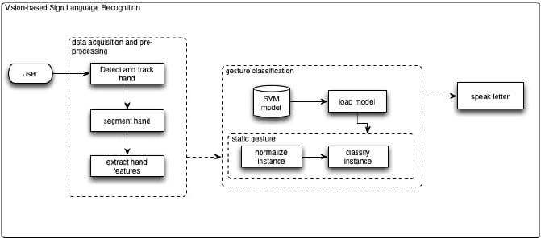

OUTLINEARCHITECTURE

